Side Event of the Consultative process towards an IMoSEB / CDB CoP 8 – March 29

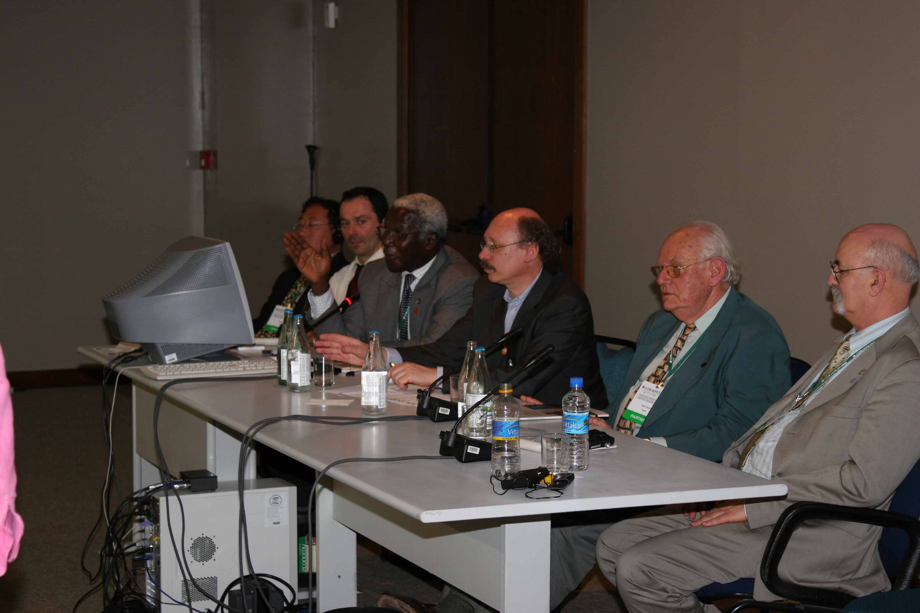
The Executive Secretariat of the Consultative Process towards an IMoSEB held a side event during the 8th Conference of the Parties of the Convention on Biological Diversity.

Alfred Oteng Yeboah, co-chair of the Executive Committee and Ignacy Sachs, socio-economist specialized in development and several members of the Executive committee were present- Jacques Weber, Horst Korn, Keping Ma - .
More than one hundred people finally attended to the side event. Some International Steering committee members were present among the participants.

The main goal of the side event was to inform the audience of the duty and goals of the Consultative process and its Executive and Steering Committees and their composition, give deeper information about the plan of action of the consultative process and generate a debate between the public, internationals observers invited and the members of the Executive committee attending at the side event.
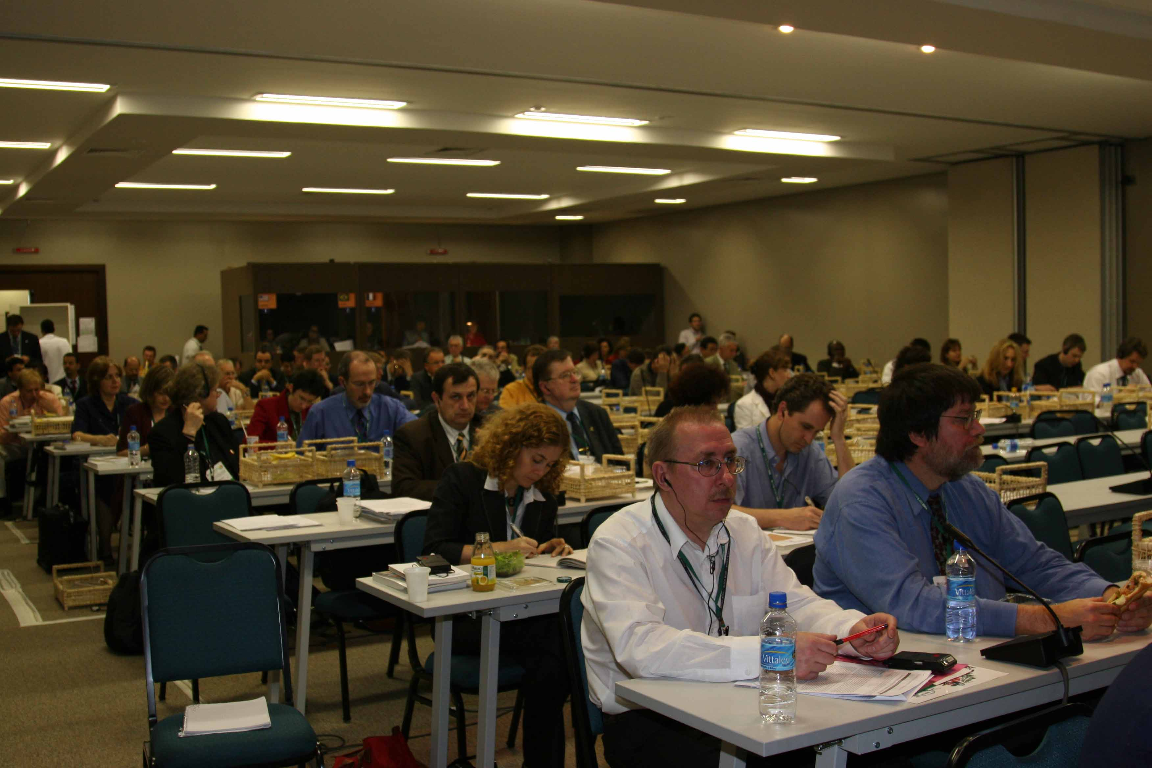

After a quick introduction by Didier Babin, Executive Secretary of the consultative process, Ahmed Djoghlaf, Executive Secretary of the Convention on Biological Diversity gave a talk and exposed his feelings regarding the consultation, asked for an accurate agenda of the consultation and expecting a successful work in the future.

Alfred Oteng Yeboah explained the current situation of the consultative process, its background, the composition of its Steering and Executive Committee.
He presented the results of the first International Steering committee meeting and the plan of action established by the Executive committee.
The first actions that need to be undertaken are to identify, define and assess the gaps and needs in the science policy interface. The consultation will be organized in two steps, the first step consisting in ordering a set of studies while continuing to inform the community, and get feedback, and the second step consisting in launching a wide consultation, based on the information collected during the first step.
Ignacy Sachs, as an international observer development planner mentioned the importance to have (1) advices on biodiversity use in development strategy and (2) advices to have a viable use of biodiversity in development strategy He underlined the positive and practical aspect of the consultation, offering to the decision-makers world the means to better integrate biodiversity in their policy.

Anne Larigauderie, member of the Executive Secretariat, hosted the general discussion

Several participants asked on the future of the consultative process (the shape, its effectiveness, its scope, its relation with others assessments), and what will be the next steps of the consultation.

Michael Wells from UNEP, wondered about the final result of the consultation and what will the “shape” of it and if it would be build on something already existing.

John Robinson, Wildlife Conservation Biology, asked for the relation with others assessments already existing as the MA and the real effectiveness of what would be decided.

Christian Pripp, CBD-SBSTTA Bureau Chairman, supported the consultative process, mentioning the usefulness of such a consultation.

The representative of Indigenous people and local community, Vladimir Bocharnikov (Roipon) and Preston Hardison (Tulalip tribes), underlined the need for local approach in the global issue of biodiversity and the need for an increased local and traditional knowledge.

Heikki Tovonen, Finish representative, stressed on the scope of the result of the consultative process, on the need to use of indicators and to clarify the scientific issues.

Anne Teller, from the European Commission mentioned that the result of the consultative process should be simple, non bureaucratic, understandable and reactive.

Leonard Hirsch, Smithsonian Institution, mentioned the quality of the discussion and the right evolution of the consultation but was concerned also by the result of the consultation – (1) Will it have a research component?, (2) Will it synthesize information?, (3) Will it translate science for decision makers ?, (4)Is it between the science academy and the consulting world?
Jacques Weber answered NO at (1), Yes at (2); Yes at (3) and Yes at (4)

Jerry Harrisson, from UNEP-WCMC, declared that the consultative process should stress on the identification of the real need.

Peter Bridgewater, Executive Secretary of the Ramsar Convention, underlined also the good evolution of the discussion in the consultation. He also mentioned the real need for better quality information in other biodiversity related conventions, even if, sometimes, right information does not lead to wise decision-making.
He underlined also a future MA should influence the role of the results of the consultation.

The overall answer of the questions given by the Executive Committee led that the consultation and its plan of action will survey, analyze and check what is happening nowadays in the transfer of scientific information towards the decision makers. The production of a new assessment is not the objective of the consultation and all the existing biodiversity related knowledge will be used. Understand how fasten decision-making processes and not overlap what has already been done will be a clear point of the consultation as well as integrate a multilevel approach and involve the local community in the process. The consultation will also involve and consult the decisions makers, create a relationship to know what kind of knowledge they want and what will be useful to them in a vision of a viable use of biodiversity.
The further step of the consultation should establish what could be the right provider of scientific information and deliver know-how to the decisions making world.
It has also been mentioned that the consultative process was open and that the Executive committee will integrate in its composition representative of the Indigenous people and of the private sector.

For more information on the consultative process, visit http://www.imoseb.net

Pictures by Maxime Thibon, Executive Secretariat of the Consultative Process

